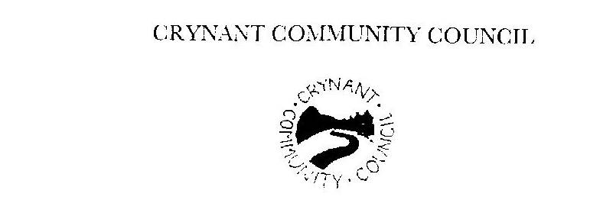

Raymond Evans, Clerk to the Council
8 Dulais Road, Seven Sisters, Neath, SA10 9EL
Telephone 01639 702974 E Mail raymond.evans2@hotmail.co.uk

Dear Councillor

The next full Council meeting of Crynant Community Council will be held at Crynant Community Centre on Thursday, 24th April 2014 at 7 pm

AGENDA

1. Apologies.

2. Register of attendance.
3. Declaration of Interest.
4. Approval of the Minutes of the full Council meeting held on 27th March 2014.

5. Matters Arising.

6. Police Report

7. County Councillor Pearson.

8. Reports

9. Planning Applications

10. Authorisations

11. Correspondence

12. Any Other Business

